Adam Evans

University of Central Lancashire

**Metabolism**

The late-modern movement of metabolism (derived from the Japanese *shinchintaisha* meaning exchange and replacement of energy and materials through the organic) arrived as an architectural language at the final CIAM meeting of 1959 in the Netherlands, where KENZ­ō TANGE (1913-2005) presented the theories of metabolism, supported by a hypothetical project entitled *Marine City* by KIYONORI KIKUTAKE (1928-2011). *Marine City* in particular became the foundation project that launched the 1960 Metabolist Manifesto entitled *Metabolism: The Proposals for New Urbanism* (published by Bitjutu Syuppan Sha) delivered in the same year at the World Design Conference in Tokyo, and provided a divergent vision for Japanese post-war modernism. Other members that formed the metabolism group included Atushi Shimokobe (1923- ), Kenji Ekuan (1929- ), Noboru Kawazoe (1926- ), Masato Otaka (1923-2010), Kiyoshi Awazu (1929-2009), Fumihiko Maki (1928- ), Uzo Nishiyama (1933- ), and KISHO KUROKAWA (1934-2007), and several of these architects and designers were students of Tange.

*Marine City,* developed as a living complex located in the ocean, represented the central ideas of metabolism, which related directly to biological processes and organic growth, and coupled with a Marxist attitude attested that people could live in harmony with nature through metabolist architecture. The design was intended as an empathetic response to the organic, incorporating a network of elliptical and curved arrival pontoons at sea level upon which high-rise concrete cylindrical towers rose to a height of 300 metres, housing some five thousand people. The process of building production was also a core idea in metabolism. In *Marine City,* a building materials factory would initially be established to provide on-site concrete manufacture for the foundations and cylinders, after production of which the factory would occupy one cylinder, and transform into a production plant for architectural and tectonic elements in order to supply the components for the housing. Once the project is complete and the occupants take residency, the factory would transform again into a monitoring station, analysing the behaviour and performance of materials, services and space, as well as becoming a production tank for future refurbishment of dilapidated housing. The refurbishment strategy utilised cranes that would literally plug-out and plug-in replacement components. This cycle of architectural events is metaphorical for the life-cycle of society and intended to support a new vision for living, as stated in the Metabolist Manifesto: “*We are not going to accept metabolism as a natural process, but try to encourage active metabolic development of our society through our proposals*.” This principle agenda was addressing several important social issues: Japan’s population boom after World War II and a potential shortage of land for dwellings, the imbalance of poverty and wealth, and agricultural production versus sustenance of the expanding human race.

The manifesto also included four important essays: *Ocean City, Space City, Towards a Group Form* and *Material and Man.* In *Ocean City,* Kikutake discusses his *Marine City* project alongside *Tower-shaped City,* and also presents the essay title as a fusion of these two projects, proposing that the future city should empathise with biological processes and that when it becomes too dilapidated to continue it would effectively die and sink into the ocean under its own weight. In *Space City* four projects of varying scales are evaluated by Kurokawa: *Neo-Tōkyō Plan, Agricultural City, Wall City,* and *Mushroom-shaped house*, building on the relationship between agriculture and society and superfluous use of space. *Towards a Group Form* (Fumihiko Maki and Mosato Otaka) appeals for the need for fluidity rather than the mega-structural approach within urban planning, and *Material and Man* (Noboru Kawazoe) attests the need to embrace nature within Japanese culture fallowing the fall-out of World War II.

Thesemacro scale projects that the manifesto presented in the 1960s, however, remained theoretical, although several significant buildings that encapsulate the values of metabolism were constructed including Tange's *Yamanashi Press and Broadcaster Centre* and *Shizuoka Press and Broadcasting Tower* (both 1966) and his buildings for the 1964 Tokyo Olympics. The urban planning agenda was ultimately executed when Tange and Nishiyama were appointed to master plan the 1970 World Exposition in Osaka, the first world fair to be held in Japan, under the theme of *Progress and Harmony for Mankind*. Utilizing 330 hectares in the Senri Hills on the outskirts of Osaka, Tange and Nishiyama developed their site strategy in-line with the Metabolist agenda, which included the dynamic *Landmark Tower* designed by Kikutake and also the *Takara Beautilion, Theme Pavilion,* and *Toshiba IHI Pavilion* designed by Kurokawa. These pavilions explicitly promoted and celebrated organic growth and renewal through the vivid expression of the architectural elements and the façade composition, in harmony with Tange and Nishiyama’s egalitarian *Festival Plaza* that appeared to reproduce and multiply through the design of the enormous steel space-deck spanning 132m. Kikutake’s tower complemented this celebration, ascending as a triangulated space-frame which housed a cluster of geodesic pods at high level.

The *Nakagin Capsule Tower* (1970-72) is composed of two interlocking towers slotted within which are 140 prefabricated modules, each being self-contained living units for solo occupancy by city professionals. The modules were each equipped with food preparation (stove, refrigerator), recreation (television, tape-player) and cleansing (bathroom capsule) facilities integrated within the walls and corners, designed to enable maximum spatial freedom within the restrictive volume of 16 cubic metres, meticulously respectful to the metabolist attitude to superfluous space. The pods themselves are prefabricated lightweight steel with a single porthole window, and the core towers a composition of steel and reinforced concrete frames, the tectonic concept borrowing much from the pioneering construction ideas of JEAN PROUVÉ. Concerns from residents about cramped living conditions were raised in 2007, suggesting the apartments have been unable to adapt to more contemporary living. Kurokawa addressed these concerns by recommending he design replacements for the existing capsules, providing updated facilities and more space, however the recession of the 2000s and fears associated with earthquake resistance of the building as a whole have created apprehension of developers to progress the remodelling works.

Metabolist urbanism shifted away from Japan following the 1973 oil crisis, however in 1986 and largely due to the economic boom of the era, Tange’s axial and linear urban design project *Plan for Tōkyō Bay* (1961) was resurrected and re-evaluated under a two-phase development proposal, and the first phase has to date influenced the development of Tokyo Bay with great effect.

Metabolism continued with some success into the 1970s, and a modest number of buildings were executed. Tange, Kikutake and Maki continued to practice, with Tange and Maki both winning the Pritzker Prize in 1987 and 1993 respectively, and Kikutake’s work still remains visually true to the metabolist aesthetic. The language of metabolism is recognisably influential to ARCHIGRAM’s rhetoric *Plug-In City* (1964), MOSHE SAFDIE’s *Habitat 67* in Montreal, Canada (1967) and RICHARD ROGERS and Renzo Piano’s *Pompidou Centre* (1972-76). Its impact continued to be significant to a range of architects practicing in the post-modern era such as Itsuko Hasegawa and Toyo Ito (both students of Kikutake), and most notably in REM KOOLHAAS’s *House at Bordeaux* (1998), and contemporary urban design project *FARMAX* (1999) by Dutch practice MVRDV.

**List of important works:**

Kenzō Tange

1960 Plan for Tokyo Bay, Tokyo

1960 Kurashiki City Hall, Kurashiki, Okayama

1966 Yamanashi Broadcasting and Press Centre, Kôfu City

1966 Shizuoka Press and Broadcasting Tower, Tokyo

1970 Osaka Expo’ Festival Plaza, Osaka

Kiyonori Kikutake

1958 Marine City (unbuilt)

1958 The Sky House, Tokyo

1970 Landmark Tower, Osaka Expo’ Osaka

1994 Hotel Sofitel, Tokyo

Kisho Kurakawa

1961 Floating City, Kasumigaura, Ibaraki

1968-70 Expo’ 70 Takara Beautilion

1968-70 Expo’ 70 Theme Pavilion

1968-70 Expo’ 70 Toshiba IHI Pavilion

1970-72 Nakagin Capsule Tower, Ginza, Tokyo

**References and further reading:**

Kurokawa, K., (1977), *Metabolism in Architecture*, Studio Vista.

Kurokawa, K., (1992), *From Metabolism to Symbiosis*, New Jersey: John Wiley & Sons.

Sorensen, A., (2002), *The Making of Urban Japan - Cities and Planning from Edo to the Twenty-first Century*, New York: Routledge.

Li, Z., (2010), *Kenzo Tange and the Metabolist Movement: Urban Utopias of Modern Japan,* London: Routledge.

Koolhaas, R., and Obrist, H. U., (2011), *Project Japan, Metabolism Talks…,* Kӧln, Germany: TASCHEN GmbH.

**Visual material:**

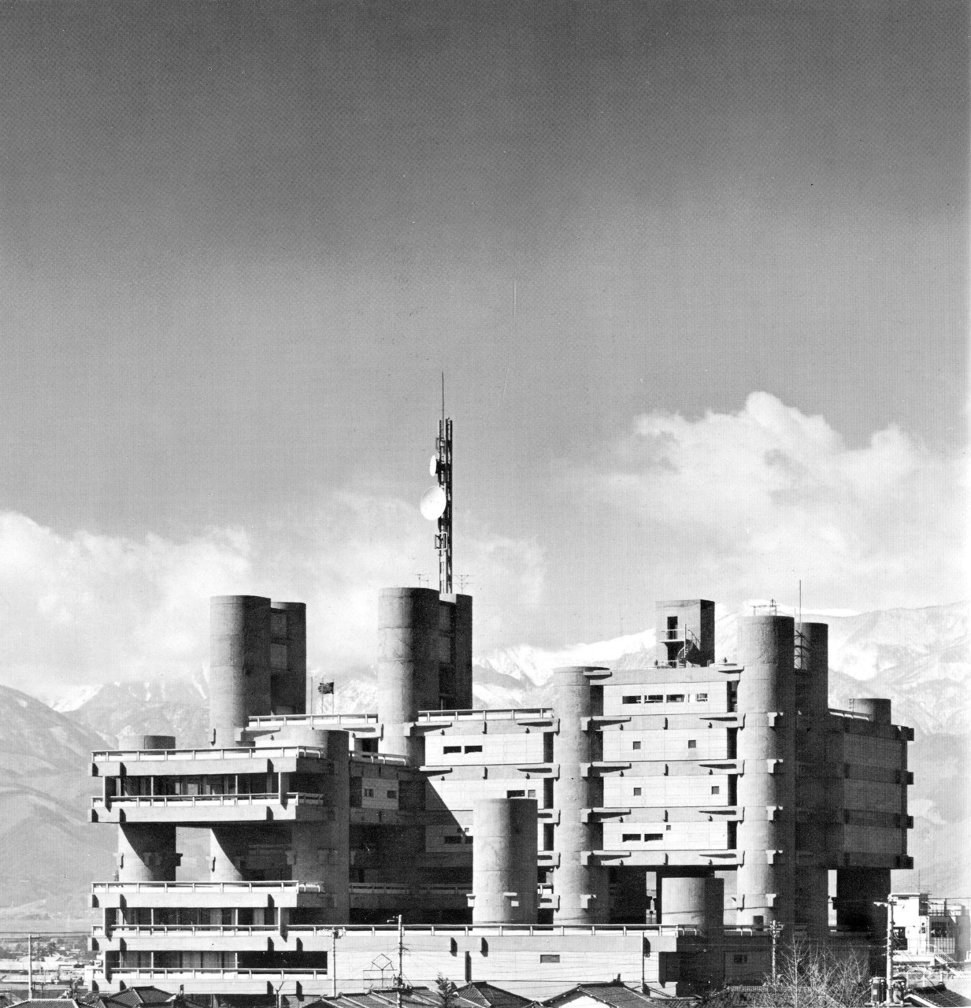

Kenzō Tange, Yamanashi Broadcasting and Press Centre, Kôfu City, Japan, 1966

Source: <http://24.media.tumblr.com/tumblr_ltagdrwh1J1qzglyyo1_1280.jpg>

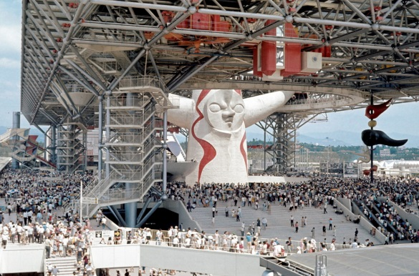

Kenzō Tange, Osaka Expo’ Festival Plaza, Osaka, Japan, 1970

Source: <http://1.bp.blogspot.com/-LT8GKvStpMw/UJGxvQlzIvI/AAAAAAAAFMM/unydjHT6kcY/s1600/expo70osaka20(38)-5a997.jpg>

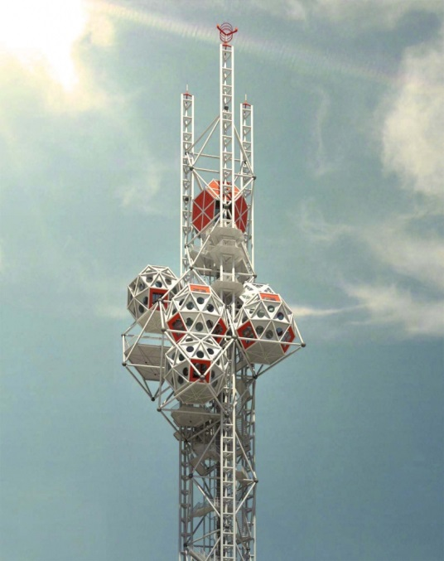

Kiyonori Kikutake, Osaka Expo’ Tower, Osaka, Japan, 1970

Source: <http://24.media.tumblr.com/tumblr_mdf41aWPlW1qzqju7o1_1280.jpg>

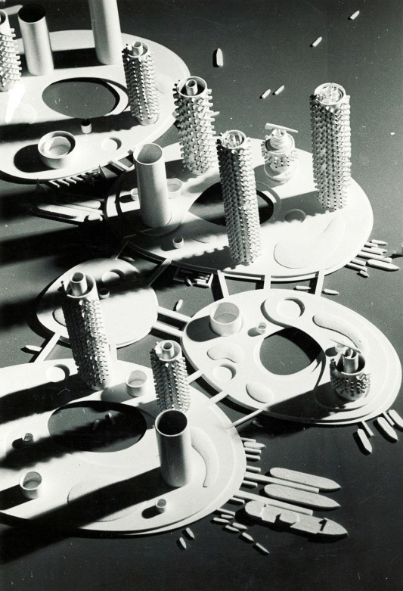

Kiyonori Kikutake, Marine City, 1958 (unbuilt)

Source: <https://www.domusweb.it/content/dam/domusweb/en/news/2011/05/03/metabolism-the-city-of-the-future/big_331716_3468_metabolism_03.jpg>

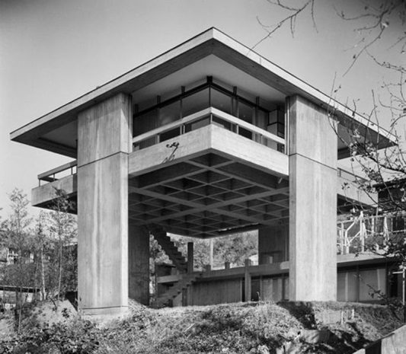

Kiyonori Kikutake, Sky House, Tokyo, Japan, 1958

Source: <http://socks-studio.com/img/blog/sky-house-00.jpg>

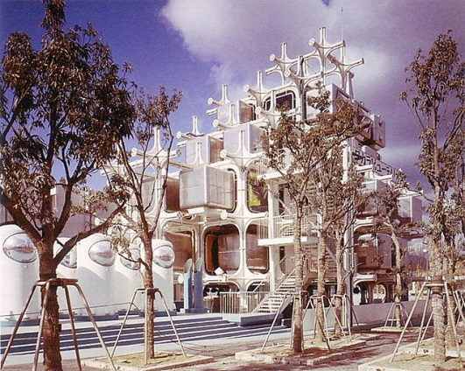

Kisho Kurakawa, Expo’ 70 Takara Beautilion, Osaka, Japan, 1968-70

Source: <http://pinktentacle.com/images/10/xexpo70_35.jpg.pagespeed.ic.62f9-6V91r.jpg>

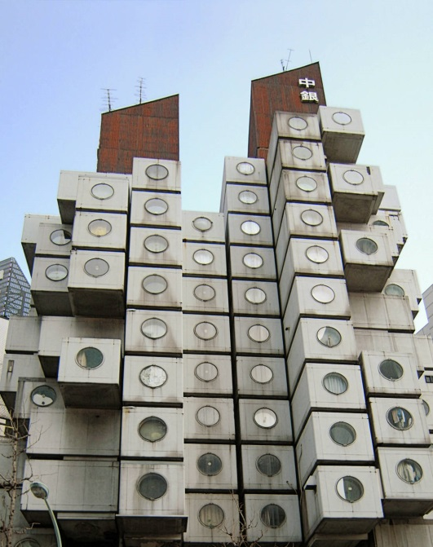

Kisho Kurakawa, Nakagin Capsule Tower, Ginza, Tokyo, 1970-72

Source: <http://farm7.staticflickr.com/6225/6272056077_053dd40ba0_o.jpg>

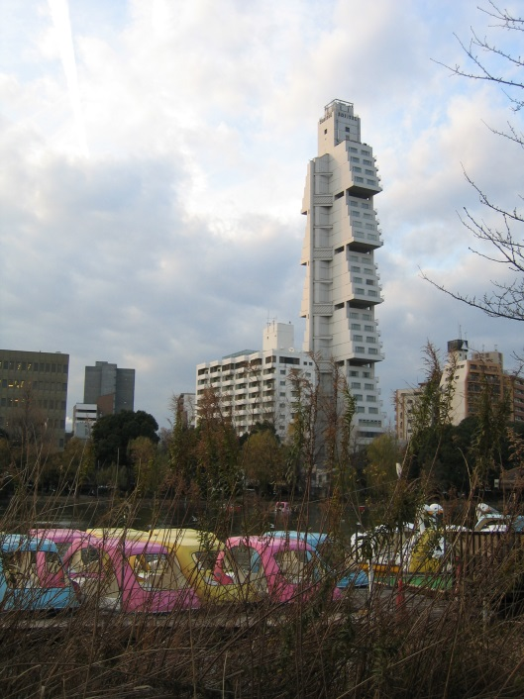

Kiyonori Kikutake, Hotel Sofitel, Tokyo, Japan, 1994

Source: <http://www.michaeljohngrist.com/wp-content/uploads/2009/2009%201jan%20sofitel/sofitelbruno.jpg>

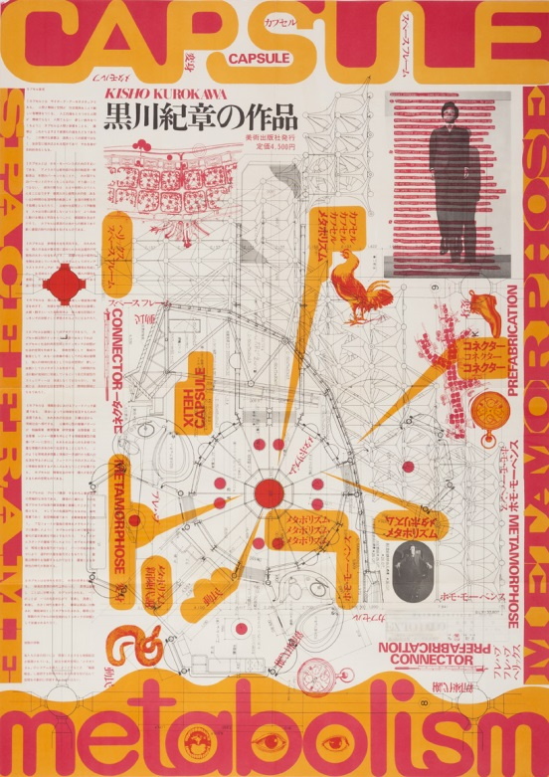

Kiyoshi Awazu, Poster for the Works of Kisho Kurokawa, 1970

Source: <http://www.frieze.com/uploads/images/middle/metabolism_1.jpg>

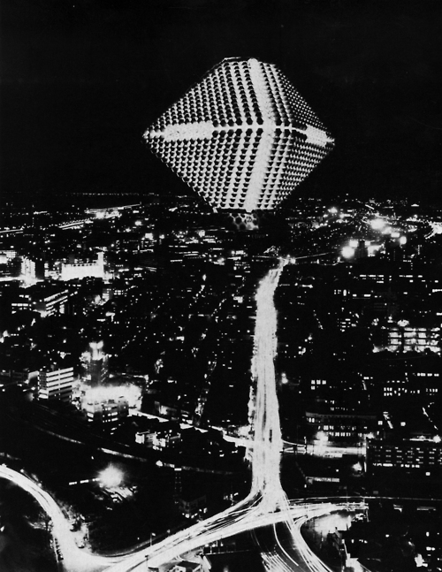

Kenji Ekuan, Dwelling City, 1964 (unbuilt)

Source: <http://24.media.tumblr.com/tumblr_lizisuyY1F1qe0nlvo1_500.jpg>